**MIN MAX**

**Aim-** Write a C program to implement Minmax Algorithm on array of integers

**Problem Statement –** Given a array of integers implement Minmax algorithm to find the minimum and maximum element in the array

**INPUT -**  Number of elements in the array – 11

Array Elements – 24,76,-4,58,23,86,-14,25,87,23,43

**OUTPUT –** Print i, j , minimum element ,maximum element during each iteration and final return maximum and minimum element in the array

**ALGORITHM –**

**i] Algorithm Minmax (I,j,max,min)**

// A global array a[i:j] is present . I and j are integer indexes in the array such that

//min<=i<=j<=max and we have to find max and min element within the array a[i:j]

{ if (i=j ) then {

min:= max:=a[i] ; }

else if (j=i+1 ) then {

if (a[i]>a[j] ) then {

max:=a[i]; min:= a[j] ; }

else then { min:= a[i] ; max:= a[j] ;} }

else then { mid:= floor((i+j)/2) ;

minmax (i,mid,max,min) ;

minmax (mid+1,j,max1,min1) ;

if (max1>max ){ max:= max1;}

if (min1<min) { min :=min1 ; }

} }

**Time and Space Complexity :**

**I] Algorithm Minmax**

**Time Complexity:**

i) **Best Case:**

* **O(n)**
* The array is divided into halves, and each element is compared exactly once as the algorithm processes all elements.

ii) **Worst Case:**

* **O(n)**
* Regardless of the arrangement of the elements, the algorithm always processes all elements through recursive division and comparisons.

iii) **Average Case:**

* **O(n)**
* On average, the algorithm divides the array into smaller segments and performs the same number of comparisons as in the best and worst cases.

**Space Complexity:**

i) **Best Case:**

* **O(log n)**
* This accounts for the recursive stack depth during the division of the array.

ii) **Worst Case:**

* **O(log n)**
* The recursion depth is logarithmic in the size of the array, which remains the same in all cases.

iii) **Average Case:**

* **O(log n)**
* On average, the recursive stack space grows logarithmically with the size of the array.

**RECURSION EQUATION :**

**I] Algorithm Minmax**

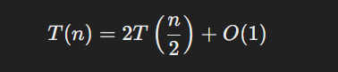

**PROGRAM –**

#include <stdio.h>

#include <time.h>

#define MAX 20

int a[MAX];

void Min_max(int low, int high, int *min, int *max) {

    int mid, min1, max1;

    if (low == high) {

        *min = *max = a[low];

        printf("i = %d, j = %d, min = %d, max = %d.\n", low, high, *min, *max);

    } else if (low == high - 1) {

        if (a[low] < a[high]) {

            *min = a[low];

            *max = a[high];

            printf("i = %d, j = %d, min = %d, max = %d.\n", low, high, *min, *max);

        } else {

            *min = a[high];

            *max = a[low];

            printf("i = %d, j = %d, min = %d, max = %d.\n", low, high, *min, *max);

        }

    } else {

        mid = (low + high) / 2;

        Min_max(low, mid, min, max);

        Min_max(mid + 1, high, &min1, &max1);

        if (min1 < *min) {

            *min = min1;

        }

        if (max1 > *max) {

            *max = max1;

        }

        printf("i = %d, j = %d, min = %d, max = %d.\n", low, high, *min, *max);

    }

}

void displayArray(int n) {

    if (n == 0) {

        printf("Array is empty.\n");

    } else {

        printf("Array elements: ");

        for (int i = 0; i < n; i++) {

            printf("|%d ", a[i]);

        }

        printf("|\n");

    }

}

int main() {

    printf("*****************************************************");

    printf("\n Roll number: 23B-CO-010\n");

    printf(" PR Number - 202311390\n");

    printf("*****************************************************\n\n\n");

    int choice, i, n = 0, min, max;

       clock_t start, end;

    double cpu_time_used;

    while (1) {

        printf("\nMenu:\n");

        printf("1. Enter array elements\n");

        printf("2. Find min and max\n");

        printf("3. Display array\n");

        printf("4. Exit\n");

        printf("Enter your choice: ");

        scanf("%d", &choice);

        switch (choice) {

            case 1:

                printf("Enter the number of elements in the array: ");

                scanf("%d", &n);

                if (n > MAX) {

                    printf("Number of elements exceeds the maximum allowed (%d). Please try again.\n", MAX);

                    n = 0;

                } else {

                    printf("Enter the elements of the array: ");

                    for (i = 0; i < n; i++) {

                        scanf("%d", &a[i]);

                    }

                }

                break;

            case 2:  start = clock();

                if (n == 0) {

                    printf("Array is empty. Please enter array elements first.\n");

                } else {

                    Min_max(0, n - 1, &min, &max);

                    printf("Minimum element: %d\n", min);

                    printf("Maximum element: %d\n", max);

                     end = clock();

                  cpu_time_used = ((double) (end - start)) / CLOCKS_PER_SEC;

                 printf("Time taken by Min_max: %f seconds\n", cpu_time_used);

                }

                break;

            case 3:

                displayArray(n);

                break;

            case 4:

                break ;

            default:

                printf("Invalid choice. Please try again.\n");

        }

    }

    return 0;

}

**INPUT –**

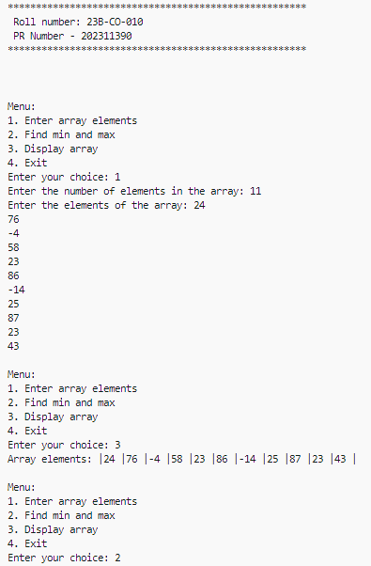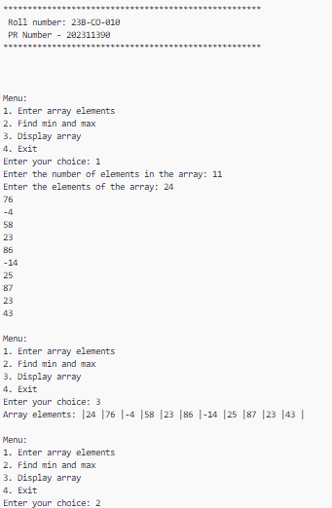

**OUTPUT –**

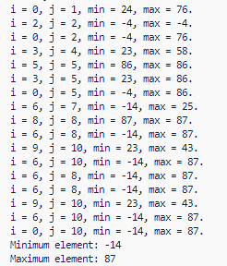

**TIME TAKEN -**



**CONCLUSION –** The maximum element and minimum element in the array was successfully calculated using Minmax Algorithm without any errors